* Arduino LED Blink :-

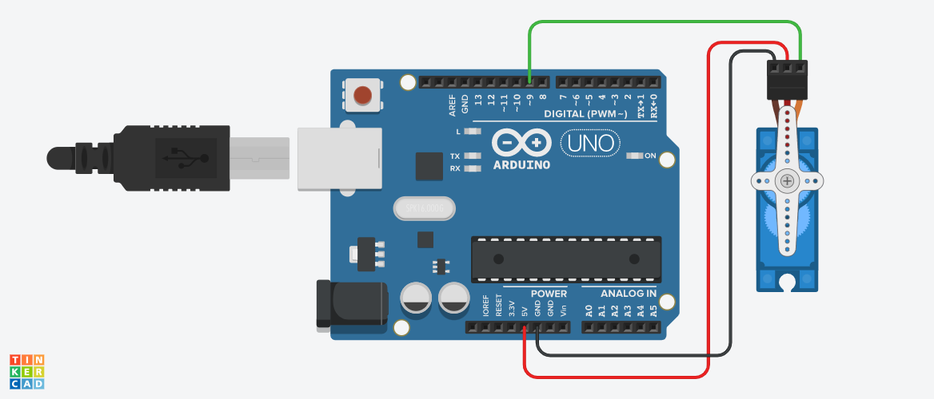

**Circuit diagram**

* **Description :-**

This project is based on **LED Blinking.** In this project LED Blink continuously like when we start simulation LED blink.In short LED Glow and off continuously. In this project we also use resistor for safety & control the current.

* **Application :-** 
  + - * + In Smartphone when any alert (call, msg…)
        + In Robotics.
        + Sensing detector.
* **Working Principle:-**

As shown in the schematic diagram below, the anode of LED is connected to VCC(+5V), and the cathode of LED is connected to the Arduino's GPIO. **When the GPIO output low level, the LED is on; when the GPIO output high level, the LED is off**.

* .**Circuit Connection :-**

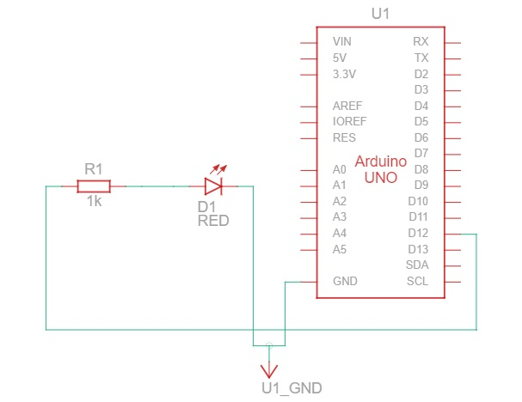

* Component List :-

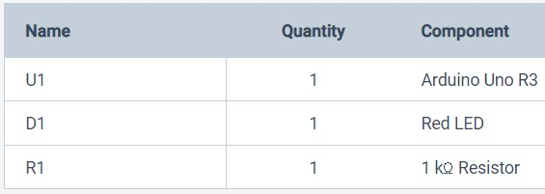

* **CODES :-**

// C++ code

//

void setup()

{

pinMode(12, OUTPUT);

}

void loop()

{

digitalWrite(12, HIGH);

delay(1000); // Wait for 1000 millisecond(s)

digitalWrite(12, LOW);

delay(1000); // Wait for 1000 millisecond(s)

}

* **BLOCKCODES :-**

